# **Password Strength Analyzer with Custom Wordlist Generator.**

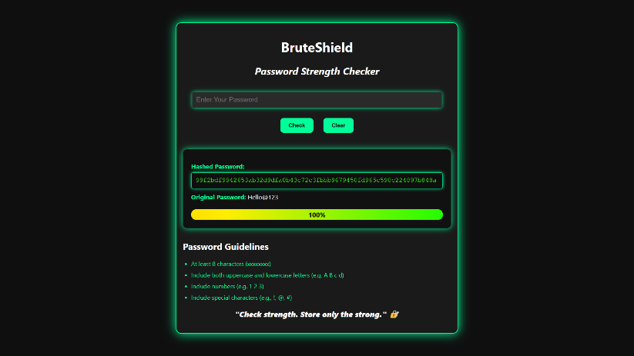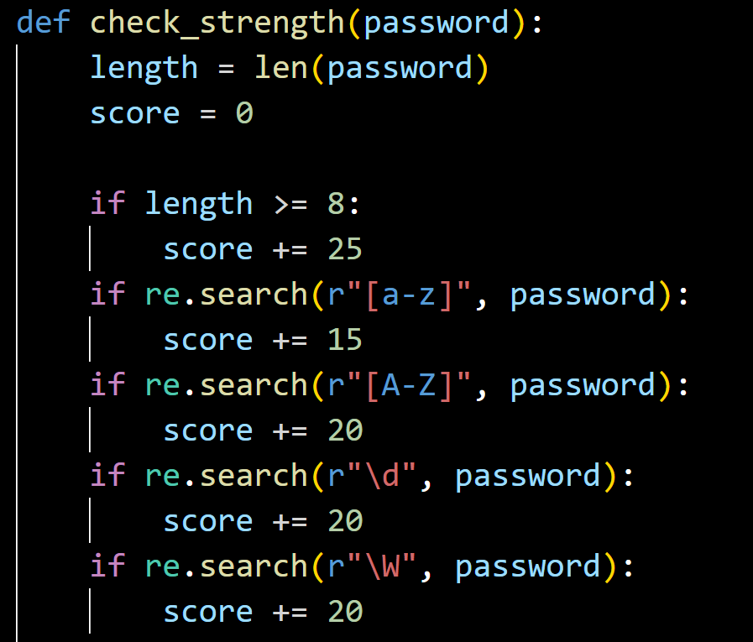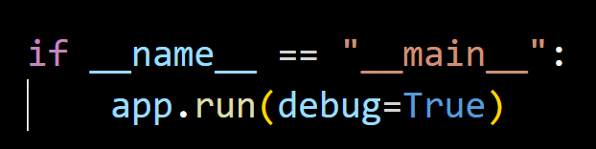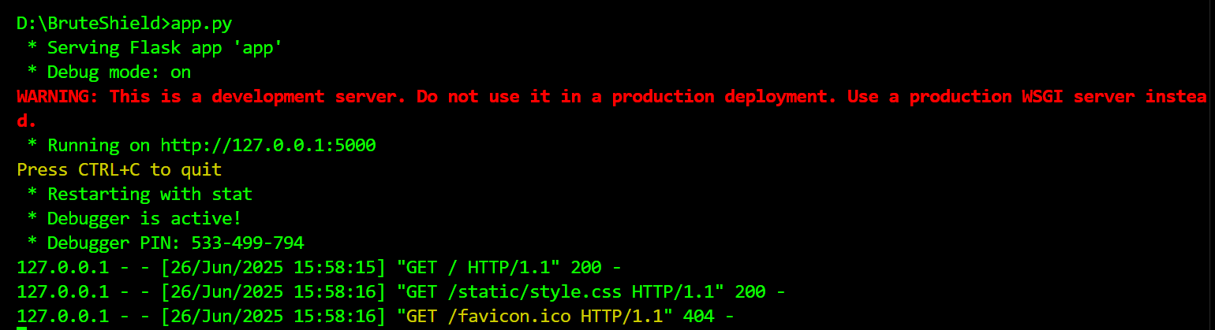

**CONCLUSION:**

Brute Shield does a great job of checking how strong a password is while also helping users learn good cybersecurity habits. It uses simple pattern checks to score password strength and shows the result clearly with a progress bar. With SHA-256 hashing for added security and a clean, user-friendly Flask interface, the tool is both powerful and easy to use.

This project also introduces important concepts like password hashing, strength calculation, and safe storage. It sets the stage for future upgrades, such as creating custom wordlists and simulating real attack methods. Overall, Brute Shield is a useful tool for anyone—whether a regular user or an ethical hacker—who wants to better understand and improve password security.